PROGRAM DEFINITION
- Program untuk menambahkan SLA Category dan SLA Call Type

RELATED TABLES
 | Access
- PMM_SLA_CATEGORY  - PMM_SLA_CALL_TYPE | - RW  - RW

ROLES
Test
- User yg mempunyai akses ke program

INITIAL PROCESS
Test
- Set VAR_COMPANY_ID = Login User’s Company ID
- Set VAR_USER_ID = Login User ID
- Set VAR_LANGUAGE_ID = Login User’s Language ID
- Jalankan RSP_GS_GET_PROPERTY_LIST dengan parameter, simpan hasil ke VAR_SELECTED_PROPERTY
  - VAR_COMPANY_ID
  - VAR_LANGUAGE_ID
- Jalankan RSP_PM_GET_SLA_CATEGORY dengan parameter, simpan hasil ke VAR_SLA_CATEGORY, VAR_SELECTED_SLA_CATEGORY dan VAR_SELECTED_LEVEL
  - VAR_COMPANY_ID
  - VAR_SELECTED_PROPERTY.CPROPERTY_ID

- Jalankan RSP_PM_GET_SLA_CATEGORY dengan parameter, simpan hasil ke VAR_SELECTED_SLA_CATEGORY dan VAR_SELECTED_LEVEL
  - VAR_COMPANY_ID
  - VAR_SELECTED_PROPERTY.CPROPERTY_ID
  - VAR_SELECTED_SLA_CATEGORY.CCATEGORY_ID

TAB SLA CATEGORY

USER INTERFACE

[CR01]
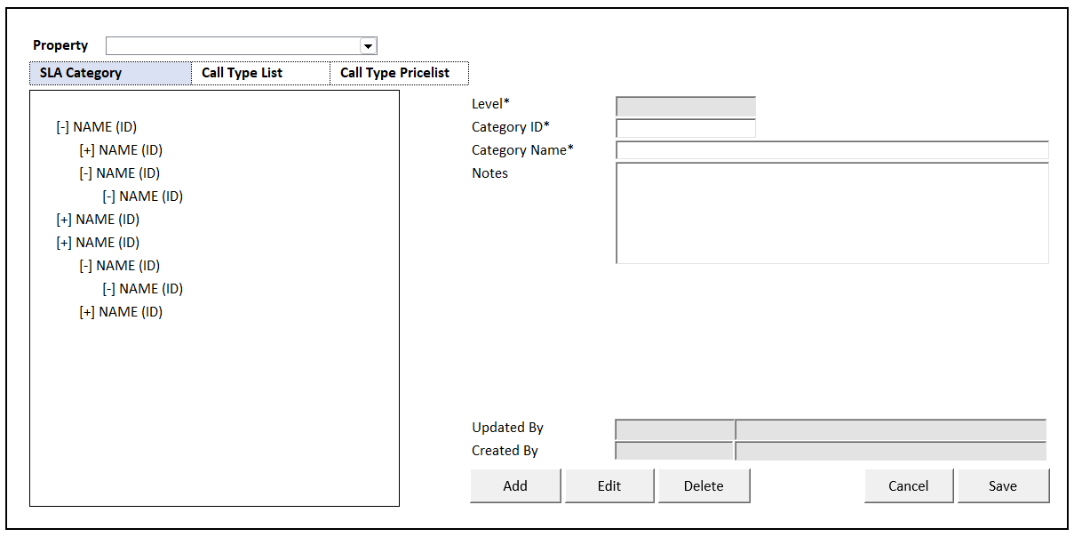

INITIAL VERSION
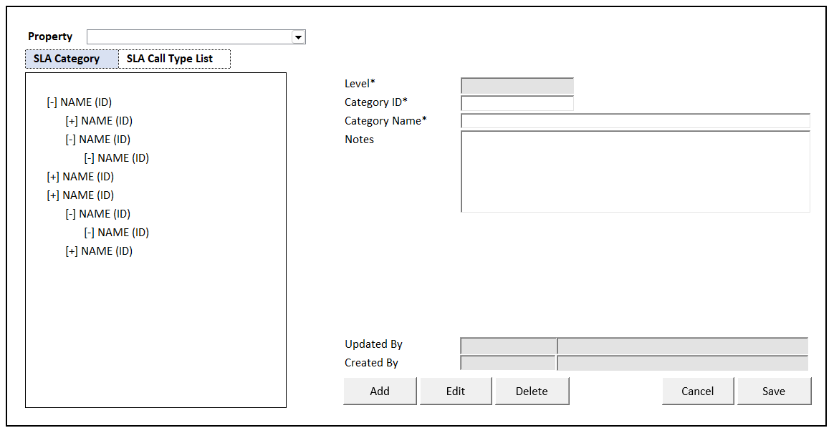

TAB DEFINITION
Tab Name | Action | Enabled
SLA Category | Go to TAB SLA CATEGORY  Jalankan Load SLA Category | - NOT on CRUD Mode
Call Type List | Go to TAB CALL TYPE LIST  Jalankan Load Call Type List | - NOT on CRUD Mode  - VAR_SLA_CATEGORY is not EMPTY
Call Type Pricelist  [CR01] | Go to TAB CALL TYPE PRICELIST  Jalankan Load Call Type List | - NOT on CRUD Mode

BUTTON DEFINITION
Button Name | Action | Enabled
Add | Jalankan ADD NEW PROCESS | - NOT on CRUD Mode
Edit | Jalankan EDIT PROCESS | - NOT on CRUD Mode  - VAR_SELECTED_SLA_CATEGORY is not EMPTY  - VAR_SELECTED_LEVEL > 0
Delete | Jalankan DELETE PROCESS | - NOT on CRUD Mode  - VAR_SELECTED_SLA_CATEGORY is not EMPTY  - VAR_SELECTED_LEVEL > 0
Cancel | Go to DISPLAY PROCESS | - On CRUD Mode
Save | Jalankan SAVE & VALIDATION PROCESS | - On CRUD Mode

ROLES
Test
- User yg punya akses ke program

INITIAL PROCESS
Test

DISPLAY PROCESS

FIELD DEFINITION
Name | Field | Type | Validation
Property | CPROPERTY_ID | Combobox  Isi combobox dengan RSP_GS_GET_PROPERTY_LIST dengan parameter  - VAR_COMPANY_ID  - VAR_USER_ID  Set ValueField = CPROPERTY_ID  Set TextField = CPROPERTY_NAME  Simpan hasil ke VAR_SELECTED_PROPERTY | On Value Changed,  IF Active Tab = ‘SLA Category’  Load SLA Category  Jalankan RSP_PM_GET_SLA_CATEGORY dengan parameter:  - VAR_COMPANY_ID  - VAR_SELECTED_PROPERTY.CPROPERTY_ID
SLA Category Tree View |  | Data: VAR_SLA_CATEGORY
SLA Category | CCATEGORY_NAME (CCATEGORY_ID) | Tree View  Load SLA Category  Isi tree view dengan RSP_PM_GET_SLA_CATEGORY dengan parameter,  - VAR_COMPANY_ID  - VAR_SELECTED_PROPERTY.CPROPERTY_ID  Simpan hasil ke VAR_SLA_CATEGORY, VAR_SELECTED_SLA_CATEGORY dan VAR_SELECTED_LEVEL | On Selected Changed,  Set VAR_SELECTED_SLA_CATEGORY = Selected data  Load SLA Category Detail  Jalankan RSP_PM_GET_SLA_CATEGORY dengan parameter:  - VAR_COMPANY_ID  - VAR_SELECTED_PROPERTY.CPROPERTY_ID  - VAR_SELECTED_SLA_CATEGORY.CCATEGORY_ID
Display Form |  | Data: VAR_SELECTED_SLA_CATEGORY
Level | ILEVEL | Textbox, Disabled, Required
Category ID | CCATEGORY_ID | Textbox, Disabled, Required
Category Name | CCATEGORY_NAME | Textbox, Disabled, Required
Parent Category ID | CPARENT_CATEGORY_ID | Hidden
Notes | CNOTES | Textbox, Disabled
Updated By | CUPDATE_BY | Textbox, Disabled
 | DUPDATE_DATE | DateTimePicker, Disabled
Created By | CCREATE_BY | Textbox, Disabled
 | DCREATE_DATE | DateTimePicker, Disabled

ADD NEW PROCESS

ACTION
- Set VAR_SAVE_MODE = ‘ADD’
- Set Display Form value:
  - Set ILEVEL = VAR_SELECTED_SLA_CATEGORY.ILEVEL + 1
  - Set CPARENT_CATEGORY_ID = VAR_SELECTED_SLA_CATEGORY.CCATEGORY_ID
- Enabled Fields: ‘Category ID’, ‘Category Name’, ‘Notes’
- Set focus to column: ‘Category ID’

- Proses:
  - ‘Save’ Go To SAVE & VALIDATION PROCESS
  - ‘Cancel’ Go To DISPLAY PROCESS

EDIT PROCESS

ACTION
- Set VAR_SAVE_MODE = ‘EDIT’
- Set Display Form value: VAR_SELECTED_SLA_CATEGORY
- Enabled Fields: ‘Category Name’, ‘Notes’
- Set focus to column: ‘Category Name’

- Proses:
  - ‘Save’ Go To SAVE & VALIDATION PROCESS
  - ‘Cancel’ Go To DISPLAY PROCESS

DELETE PROCESS

ACTION
- Set VAR_SAVE_MODE = ‘DELETE’

- Delete SLA Process
Jalankan RSP_PM_MAINTAIN_SLA_CATEGORY dengan parameter,
@CCOMPANY_ID = VAR_COMPANY_ID
@CPROPERTY_ID = VAR_SELECTED_PROPERTY.CPROPERTY_ID
@CCATEGORY_ID = ‘Category ID’
@CCATEGORY_NAME = ‘Category Name’
@CPARENT_CATEGORY_ID = ‘Parent Category ID’
@ILEVEL = ‘Level’
@CNOTES = ‘Notes’
@CACTION = ‘DELETE’
@CUSER_ID = VAR_USER_ID

SAVE & VALIDATION PROCESS

VALIDATION
Field | Condition | Validation Message
Category ID | Empty | Please fill Category ID!
Category Name | Empty | Please fill Category Name!

ACTION
- Validate (See VALIDATION table)
IF Success, jalankan Save SLA CATEGORY
IF Failed, stay on Add/Edit Process

- Save SLA Category
Jalankan RSP_PM_MAINTAIN_SLA_CATEGORY dengan parameter,
@CCOMPANY_ID = VAR_COMPANY_ID
@CPROPERTY_ID = VAR_SELECTED_PROPERTY.CPROPERTY_ID
@CCATEGORY_ID = ‘Category ID’
@CCATEGORY_NAME = ‘Category Name’
@CPARENT_CATEGORY_ID = ‘Parent Category ID’
@ILEVEL = ‘Level’
@CNOTES = ‘Notes’
@CACTION = VAR_SAVE_MODE
@CUSER_ID = VAR_USER_ID

- Go to DISPLAY PROCESS

TAB CALL TYPE LIST

USER INTERFACE

[CR01]
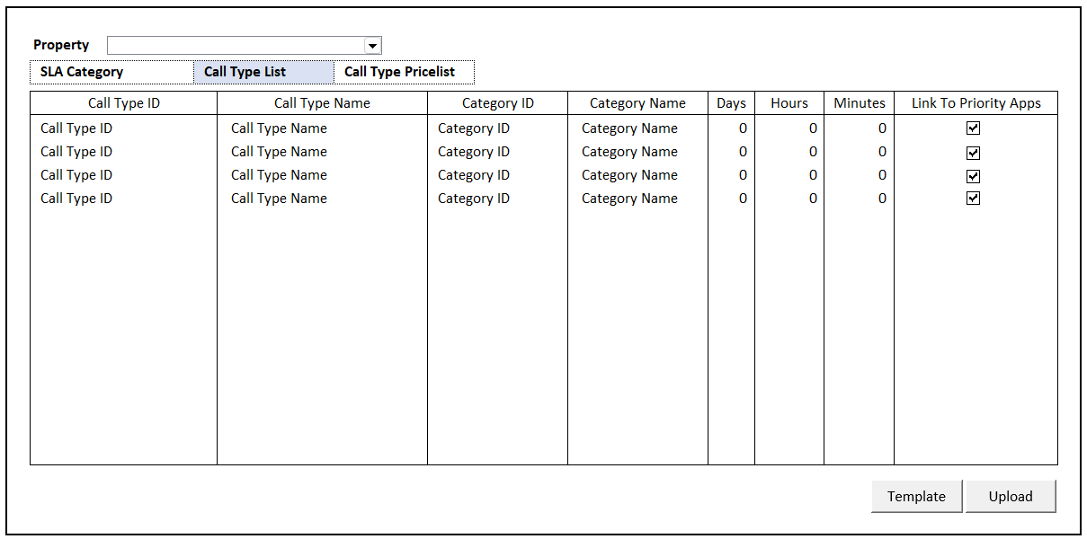

INITIAL VERSION
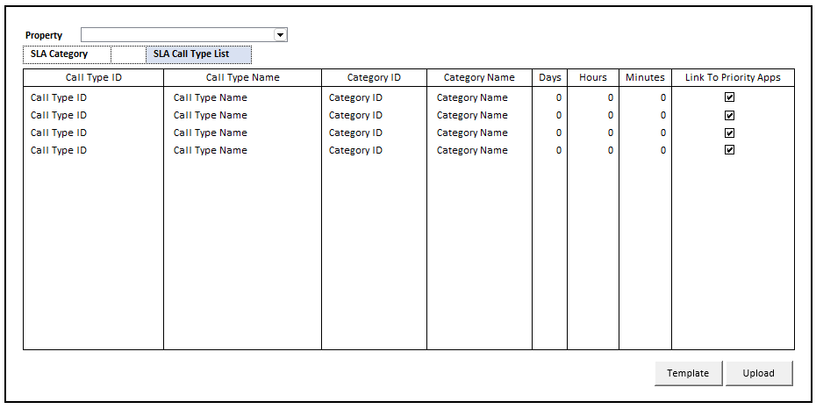

BUTTON DEFINITION
Button Name | Action | Enabled
Template | Jalankan DOWNLOAD TEMPLATE PROCESS | - NOT on CRUD Mode
Upload | Jalankan UPLOAD PROCESS | - NOT on CRUD Mode

ROLES
Test
- User yg punya akses ke program

INITIAL PROCESS
Test
- Load Call Type List
Jalankan RSP_PM_GET_SLA_CALL_TYPE_LIST dengan parameter, simpan hasil ke VAR_CALL_TYPE_LIST dan VAR_SELECTED_CALL_TYPE
  - VAR_COMPANY_ID
  - VAR_SELECTED_PROPERTY.CPROPERTY_ID

- Load Call Type Detail
Jalankan RSP_PM_GET_SLA_CALL_TYPE_LIST dengan parameter, simpan
  - VAR_COMPANY_ID
  - VAR_SELECTED_PROPERTY.CPROPERTY_ID
  - VAR_SELECTED_CALL_TYPE.CCALL_TYPE_ID

DISPLAY PROCESS

FIELD DEFINITION
Name | Field | Type | Validation
Property | CPROPERTY_ID | Combobox  Isi combobox dengan RSP_GS_GET_PROPERTY_LIST dengan parameter  - VAR_COMPANY_ID  - VAR_USER_ID  Set ValueField = CPROPERTY_ID  Set TextField = CPROPERTY_NAME  Simpan hasil ke VAR_SELECTED_PROPERTY | On Value Changed,  IF Active Tab = ‘Call Type List’  Load Call Type List  Jalankan RSP_PM_GET_SLA_CALL_TYPE_LIST dengan parameter:  - VAR_COMPANY_ID  - VAR_SELECTED_PROPERTY.CPROPERTY_ID
Call Type List Grid |  | Data: VAR_CALL_TYPE_LIST | Allow:  ADD Jalankan Add New Process  EDIT Jalankan Edit Process  DELETE Jalankan Delete Process  On Selected Changed,  Set VAR_SELECTED_CALL_TYPE = Selected row data  Load Call Type Detail  Jalankan RSP_PM_GET_SLA_CALL_TYPE_LIST dengan parameter:  - VAR_COMPANY_ID  - VAR_SELECTED_PROPERTY.CPROPERTY_ID  - VAR_SELECTED_CALL_TYPE.CCALL_TYPE_ID
Call Type ID | CCALL_TYPE_ID | Textbox, Disabled, Required | Enabled: on ADD
Call Type Name | CCALL_TYPE_NAME | Textbox, Disabled, Required | Enabled: on ADD & EDIT
Category ID | CCATEGORY_ID | Lookup, Disabled, Required | Enabled: on ADD & EDIT  On Lost Focus  Go to LOOKUP PROCESS  On Lookup Button clicked  Go to LOOKUP PROCESS  On value change, update:  CCATEGORY_ID, CCATEGORY_NAME
Category Name | CCATEGORY_NAME | Textbox, Disabled, Required
Days | IDAYS | NumericTextBox, Disabled | No Arrows  Decimal Places = 0  Enabled: on ADD & EDIT
Hours | IHOURS | NumericTextBox, Disabled | No Arrows  Decimal Places = 0  Enabled: on ADD & EDIT
Minutes | IMINUTES | NumericTextBox, Disabled | No Arrows  Decimal Places = 0  Enabled: on ADD & EDIT
Link To Priority Apps | LPRIORITY | Checkbox, Disabled | Enabled: on ADD & EDIT

ADD NEW PROCESS

ACTION
- Set VAR_SAVE_MODE = ‘ADD’
- Enabled Fields: ‘Call Type ID’, ‘Call Type Name’, ‘Category’, ‘Days, ‘Hours’, ‘Minutes’, ‘Link To Priority Apps’
- Set focus to column: ‘Call Type ID’

- Proses:
  - ‘Save’ Go To SAVE & VALIDATION PROCESS
  - ‘Cancel’ Go To DISPLAY PROCESS

EDIT PROCESS

ACTION
- Set VAR_SAVE_MODE = ‘EDIT’
- Enabled Fields: ‘Call Type Name’, ‘Category’, ‘Days, ‘Hours’, ‘Minutes’, ‘Link To Priority Apps’
- Set focus to column: ‘Call Type Name’

- Proses:
  - ‘Save’ Go To SAVE & VALIDATION PROCESS
  - ‘Cancel’ Go To DISPLAY PROCESS

DELETE PROCESS

ACTION
- Set VAR_SAVE_MODE = ‘DELETE’

- Delete Sla Call Type
Jalankan RSP_PM_MAINTAIN_SLA_CALL_TYPE dengan parameter,
@CCOMPANY_ID = VAR_COMPANY_ID
@CPROPERTY_ID = VAR_SELECTED_PROPERTY.CPROPERTY_ID
@CCALL_TYPE_ID = ‘Call Type ID’
@CCALL_TYPE_NAME = ‘Call Type Name’
@CCATEGORY_ID = ‘Category ID’
@IDAYS = ‘Days’
@IHOURS = ‘Hours’
@IMINUTES = ‘Minutes’
@LPRIORITY = ‘Link To Priority Apps’
@CACTION = ‘DELETE’
@CUSER_ID = VAR_USER_ID

SAVE & VALIDATION PROCESS

VALIDATION
Field | Condition | Validation Message
Call Type ID | Empty | Please fill Call Type ID!
Call Type Name | Empty | Please fill Call Type Name!
Category | Empty | Please fill Category!
Days | Value < 0 | Negative days value is not allowed!
Hours | Value < 0 | Negative hours value is not allowed!
Minutes | Value < 0 | Negative minutes value is not allowed!

ACTION
- Validate (See VALIDATION table)
IF Success, jalankan Save SLA Call Type
IF Failed, stay on Add/Edit Process

- Save SLA Call Type
Jalankan RSP_PM_MAINTAIN_SLA_CALL_TYPE dengan parameter,
@CCOMPANY_ID = VAR_COMPANY_ID
@CPROPERTY_ID = VAR_SELECTED_PROPERTY.CPROPERTY_ID
@CCALL_TYPE_ID = ‘Call Type ID’
@CCALL_TYPE_NAME = ‘Call Type Name’
@CCATEGORY_ID = ‘Category ID’
@IDAYS = ‘Days’
@IHOURS = ‘Hours’
@IMINUTES = ‘Minutes’
@LPRIORITY = ‘Link To Priority Apps’
@CACTION = VAR_SAVE_MODE
@CUSER_ID = VAR_USER_ID
- Go to DISPLAY PROCESS

LOOKUP PROCESS

ON LOST FOCUS

PARAMETER
Parameter Name | Description
CPROPERTY_ID | VAR_SELECTED_PROPERTY.CPROPERTY_ID from TAB CALL TYPE LIST
CSEARCH_TEXT | Category ID column’s value

ACTION
- Run PML01500 – SLA Category Lookup dengan parameter:
  - CPROPERTY_ID
  - CSEARCH_TEXT
- TAB SLA CALL TYPE’s GRID stay on CRUD MODE
- Set TAB SLA CALL TYPE’s GRID
CCATEGORY_ID = LOOKUP_RETURN_VALUE.CCATEGORY_ID
CCATEGORY_NAME = LOOKUP_RETURN_VALUE.CCATEGORY_NAME

BEFORE OPEN LOOKUP

PARAMETER
Parameter Name | Description
CPROPERTY_ID | VAR_SELECTED_PROPERTY.CPROPERTY_ID from TAB CALL TYPE LIST

ACTION
- Run PML01500 – SLA Category Lookup dengan parameter:
  - CPROPERTY_ID

AFTER OPEN LOOKUP

CANCEL PROCESS

ACTION
- Close this POPUP
- TAB SLA CALL TYPE’s GRID stay on CRUD MODE

LOOKUP SELECT DATA PROCESS

ACTION
- Close lookup
- TAB SLA CALL TYPE’s GRID stay on CRUD MODE
- Set TAB SLA CALL TYPE’s GRID
CCATEGORY_ID = LOOKUP_RETURN_VALUE.CCATEGORY_ID
CCATEGORY_NAME = LOOKUP_RETURN_VALUE.CCATEGORY_NAME

DOWNLOAD TEMPLATE PROCESS

ACTION
- Download Call Type List File from Server
Download Filename: ‘SLACallTypeListTemplate.xlsx

- Tampilkan file directory untuk proses Save As Download oleh user

UPLOAD PROCESS

USER INTERFACE

INITIAL VERSION
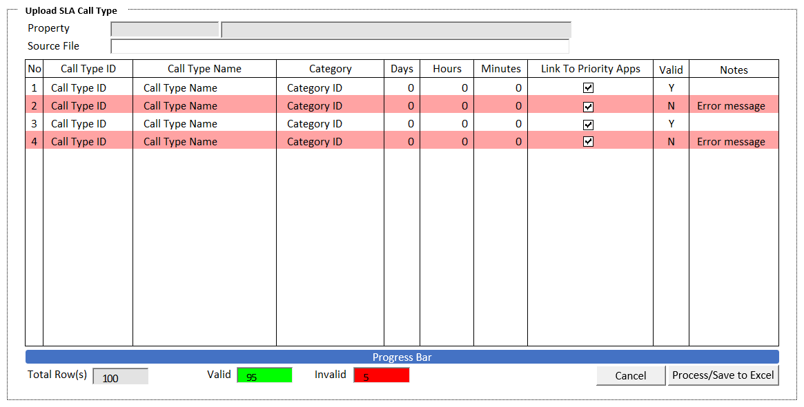

BUTTON DEFINITION
Button Name | Action | Enabled
Cancel | Jalankan CANCEL PROCESS
Process | Jalankan PROCESS | - XLSX File Load Successfully  - VAR_TOTAL_ROWS > 0
Save to Excel | Jalankan SAVE TO EXCEL PROCESS | - Handled Error found in PROCESS

INPUT PARAMETER
Parameter Name | Description
PARAM_PROPERTY_ID | VAR_SELECTED_PROPERTY.CPROPERTY_ID from TAB CALL TYPE LIST
PARAM_PROPERTY_NAME | VAR_SELECTED_PROPERTY.CPROPERTY_NAME from TAB CALL TYPE LIST

ROLES
Test
- User yg punya akses ke program

INITIAL PROCESS
Test
- Load data from Input Parameter
- Set VAR_SOURCE_FILE = ‘’
- Set VAR_TOTAL_ROWS = 0
- Set VAR_VALID_ROWS = 0
- Set VAR_INVALID_ROWS = 0
- Set Focus pada Source File Input

DISPLAY PROCESS

FIELD DEFINITION
Name | Field | Type | Validation
Property | PARAM_PROPERTY_ID | Textbox, Disabled
 | PARAM_PROPERTY_NAME | Textbox, Disabled
Source File | VAR_SOURCE_FILE | FileInput  Simpan data ke VAR_UPLOAD_LIST, VAR_TOTAL_ROWS | Accepts: .xlsx (Microsoft Excel)  Read Excel dari SheetName ‘SLACallType’  IF VAR_SOURCE_FILE is not Excel File  - Show message “File Type must Microsoft Excel .xlsx!”  IF VAR_SOURCE_FILE is empty  - Show message “File is empty!”
Call Type List Upload Grid |  | Data: VAR_UPLOAD_LIST / VAR_RESULT | Allow: -  ViewOnly  If CVALID = ‘N’, RenderRow with background color ‘light red’
No | INO | Textbox, Disabled
Call Type ID | CCALL_TYPE_ID | Textbox, Disabled, Required
Call Type Name | CCALL_TYPE_NAME | Textbox, Disabled, Required
Category | CCATEGORY_ID | Textbox, Disabled, Required
Days | IDAYS | NumericTextBox, Disabled
Hours | IHOURS | NumericTextBox, Disabled
Minutes | IMINUTES | NumericTextBox, Disabled
Link To Priority Apps | LPRIORITY | Checkbox, Disabled
Valid | CVALID | Textbox, Disabled
Notes | CNOTES | Textbox, Disabled
Footer
Total Rows | VAR_TOTAL_ROWS | Textbox, Disabled
Valid | VAR_VALID_ROWS | Textbox, Disabled  Background Color: Green | Update after PROCESS
Invalid | VAR_INVALID_ROWS | Textbox, Disabled  Background Color: Red | Update after PROCESS

CANCEL PROCESS

ACTION
- Close this POPUP
- Jalankan TAB SLA CALL TYPE’s DISPLAY PROCESS

PROCESS

ACTION
- Set Progess bar step = 9 steps
- Set VAR_KEY_GUID = New GUID
- Set VAR_ERROR_COUNT = 0
- Reset Progress Bar

- Buat temporary table

CREATE TABLE #UPLOAD_SLA(
NO INT NOT NULL
, CCOMPANY_ID VARCHAR(8) NOT NULL
, CPROPERTY_ID VARCHAR(20) NOT NULL
, CCALL_TYPE_ID VARCHAR(20) NOT NULL
, CCALL_TYPE_NAME NVARCHAR(100) NOT NULL
, CCATEGORY_ID VARCHAR(20) NOT NULL
, IDAYS INT NOT NULL
, IHOURS INT NOT NULL
, IMINUTES INT NOT NULL
, LPRIOIRTY BIT NOT NULL
)

- Insert VAR_UPLOAD_LIST into #UPLOAD_SLA

- Jalankan RSP_PM_UPLOAD_SLA_PROCESS dengan parameter, simpan hasil ke VAR_RESULT
@CCOMPANY_ID = VAR_COMPANY_ID
@CPROPERTY_ID = VAR_SELECTED_PROPERTY.CPROPERTY_ID
@CUSER_ID = VAR_USER_ID
@CKEY_GUID = VAR_KEY_GUID

- Set Upload Grid DATA SOURCE = VAR_RESULT

- Go To ‘DISPLAY PROCESS’

SAVE TO EXCEL PROCESS
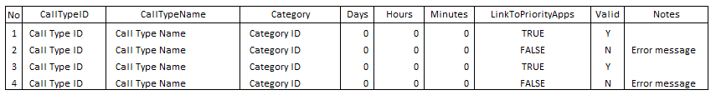

ACTION
- Generate Template Process
Buat template dengan detail sebagai berikut:
No
CallTypeID
CallTypeName
Category
Days
Hours
Minutes
LinkToPriorityApps
Valid
Notes
Set Excel Sheet Name = ‘SLACallType’

- Create File Excel
- Tampilkan file directory untuk proses Save As Download oleh user

TAB CALL TYPE PRICELIST [CR01]

USER INTERFACE

INITIAL VERSION
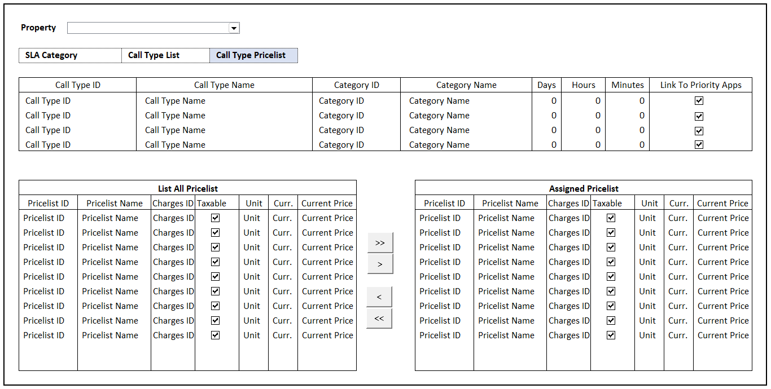

BUTTON DEFINITION
Button Name | Action | Enabled
>> | Jalankan ASSIGN PROCESS | - VAR_ALL_PRICELIST is not Empty
> | Jalankan ASSIGN PROCESS | - VAR_SELECTED_PRICELIST is not null
< | Jalankan UNASSIGN PROCESS | - VAR_SELECTED_ASSIGNED_PRICELIST is not null
<< | Jalankan UNASSIGN PROCESS | - VAR_ASSIGNED_PRICELIST is not Empty

ROLES
Test
- User yg punya akses ke program

INITIAL PROCESS
Test
- Load Call Type List
Jalankan RSP_PM_GET_SLA_CALL_TYPE_LIST dengan parameter, simpan hasil ke VAR_CALL_TYPE_LIST dan VAR_SELECTED_CALL_TYPE
  - VAR_COMPANY_ID
  - VAR_SELECTED_PROPERTY.CPROPERTY_ID

- Load Call Type Detail
Jalankan RSP_PM_GET_SLA_CALL_TYPE_LIST dengan parameter, simpan hasil ke VAR_SELECTED_CALL_TYPE
  - VAR_COMPANY_ID
  - VAR_SELECTED_PROPERTY.CPROPERTY_ID
  - VAR_SELECTED_CALL_TYPE.CCALL_TYPE_ID

- Load All Pricelist
Jalankan RSP_PM_GET_CALL_TYPE_PRICELIST_LIST dengan parameter, simpan hasil ke VAR_ALL_PRICELIST
  - VAR_COMPANY_ID
  - VAR_SELECTED_PROPERTY.CPROPERTY_ID
  - VAR_SELECTED_CALL_TYPE.CCALL_TYPE_ID
  - VAR_LANGUAGE_ID

- Load Assigned Pricelist
Jalankan RSP_PM_GET_CALL_TYPE_ASSIGNED_PRICELIST_LIST dengan parameter, simpan hasil ke VAR_ASSIGNED_PRICELIST
  - VAR_COMPANY_ID
  - VAR_SELECTED_PROPERTY.CPROPERTY_ID
  - VAR_SELECTED_CALL_TYPE.CCALL_TYPE_ID
  - VAR_LANGUAGE_ID

DISPLAY PROCESS

FIELD DEFINITION
Name | Field | Type | Validation
Property | CPROPERTY_ID | Combobox  Isi combobox dengan RSP_GS_GET_PROPERTY_LIST dengan parameter  - VAR_COMPANY_ID  - VAR_USER_ID  Set ValueField = CPROPERTY_ID  Set TextField = CPROPERTY_NAME  Simpan hasil ke VAR_SELECTED_PROPERTY | On Value Changed,  IF Active Tab = ‘Call Type List’  Load Call Type List  Jalankan RSP_PM_GET_SLA_CALL_TYPE_LIST dengan parameter:  - VAR_COMPANY_ID  - VAR_SELECTED_PROPERTY.CPROPERTY_ID
Call Type List Grid |  | Data: VAR_CALL_TYPE_LIST | Allow: -  View Only  On Selected Changed,  Set VAR_SELECTED_CALL_TYPE = Selected row data  Load Call Type Detail  Jalankan RSP_PM_GET_SLA_CALL_TYPE_LIST dengan parameter:  - VAR_COMPANY_ID  - VAR_SELECTED_PROPERTY.CPROPERTY_ID  - VAR_SELECTED_CALL_TYPE.CCALL_TYPE_ID  Load All Pricelist  Jalankan RSP_PM_GET_CALL_TYPE_PRICELIST_LIST dengan parameter:  - VAR_COMPANY_ID  - VAR_SELECTED_PROPERTY.CPROPERTY_ID  - VAR_SELECTED_CALL_TYPE.CCALL_TYPE_ID  - VAR_LANGUAGE_ID  Simpan hasil ke VAR_ALL_PRICELIST  Load Assign Pricelist  Jalankan RSP_PM_GET_CALL_TYPE_ASSIGN_PRICELIST_LIST dengan parameter:  - VAR_COMPANY_ID  - VAR_SELECTED_PROPERTY.CPROPERTY_ID  - VAR_SELECTED_CALL_TYPE.CCALL_TYPE_ID  - VAR_LANGUAGE_ID  Simpan hasil ke VAR_ASSIGNED_PRICELIST
Call Type ID | CCALL_TYPE_ID | Textbox, Disabled
Call Type Name | CCALL_TYPE_NAME | Textbox, Disabled
Category ID | CCATEGORY_ID | Textbox, Disabled
Category Name | CCATEGORY_NAME | Textbox, Disabled
Days | IDAYS | NumericTextBox, Disabled | No Arrows  Decimal Places = 0
Hours | IHOURS | NumericTextBox, Disabled | No Arrows  Decimal Places = 0
Minutes | IMINUTES | NumericTextBox, Disabled | No Arrows  Decimal Places = 0
Link To Priority Apps | LPRIORITY | Checkbox, Disabled
List All Pricelist Grid |  | Data: VAR_ALL_PRICELIST | Allow: -  View Only  On Selected Changed,  Set VAR_SELECTED_PRICELIST = Selected row data
Pricelist ID | CPRICELIST_ID | Textbox, Disabled
Pricelist Name | CPRICELIST_NAME | Textbox, Disabled
Charges ID | CCHARGES_ID | Textbox, Disabled
Taxable | LTAXABLE | Checkbox, Disabled
Unit | CUNIT | TextBox, Disabled
Curr. | CCURRENCY_CODE | TextBox, Disabled
Current Price | IPRICE | NumericTextBox, Disabled | No Arrows  Decimal Places = 2
Assigned Pricelist Grid |  | Data: VAR_ASSIGNED_PRICELIST | Allow: -  View Only  On Selected Changed,  Set VAR_SELECTED_ASSIGNED_PRICELIST = Selected row data
Pricelist ID | CPRICELIST_ID | Textbox, Disabled
Pricelist Name | CPRICELIST_NAME | Textbox, Disabled
Charges ID | CCHARGES_ID | Textbox, Disabled
Taxable | LTAXABLE | Checkbox, Disabled
Unit | CUNIT | TextBox, Disabled
Curr. | CCURRENCY_CODE | TextBox, Disabled
Current Price | IPRICE | NumericTextBox, Disabled | No Arrows  Decimal Places = 2

ASSIGN PROCESS

ACTION
- IF “<” is Pressed then,
Set VAR_PRICELIST_ID = ‘’
Tambahkan CPRICELIST_ID dari VAR_SELECTED_PRICELIST ke VAR_PRICELIST_ID dan pisahkan dengan koma.
Ex: ‘PRC-001,PRC-002,PRC-003’
- Else,
Set VAR_PRICELIST_ID = ‘’
Tambahkan CPRICELIST_ID dari VAR_ALL_PRICELIST ke VAR_PRICELIST_ID dan pisahkan dengan koma.
Ex: ‘PRC-001,PRC-002,PRC-003’

- Assign Pricelist
Jalankan RSP_PM_ASSIGN_PRICELIST dengan parameter,
@CCOMPANY_ID = VAR_COMPANY_ID
@CPROPERTY_ID = VAR_SELECTED_PROPERTY.CPROPERTY_ID
@CCALL_TYPE_ID = VAR_SELECTED_CALL_TYPE.CCALL_TYPE_ID
@CPRICELIST_ID = VAR_PRICELIST_ID
@CUSER_ID = VAR_USER_ID

UNASSIGN PROCESS

ACTION
- IF “<” is Pressed then,
Set VAR_ASSIGNED_PRICELIST_ID = ‘’
Tambahkan CPRICELIST_ID dari VAR_SELECTED_ASSIGNED_PRICELIST ke VAR_ASSIGNED_PRICELIST_ID dan pisahkan dengan koma.
Ex: ‘PRC-001,PRC-002,PRC-003’
- Else,
Set VAR_ASSIGNED_PRICELIST_ID = ‘’
Tambahkan CPRICELIST_ID dari VAR_ASSIGNED_PRICELIST ke VAR_ASSIGNED_PRICELIST_ID dan pisahkan dengan koma.
Ex: ‘PRC-001,PRC-002,PRC-003’

- Assign Pricelist
Jalankan RSP_PM_UNASSIGN_PRICELIST dengan parameter,
@CCOMPANY_ID = VAR_COMPANY_ID
@CPROPERTY_ID = VAR_SELECTED_PROPERTY.CPROPERTY_ID
@CCALL_TYPE_ID = VAR_SELECTED_CALL_TYPE.CCALL_TYPE_ID
@CPRICELIST_ID = VAR_ASSIGNED_PRICELIST_ID
@CUSER_ID = VAR_USER_ID

- Go to DISPLAY PROCESS

CR LIST
CR | Description | Notes
CR01  NS, 18 Des 2024 | - Menambahkan Tab Call Type Checklist

